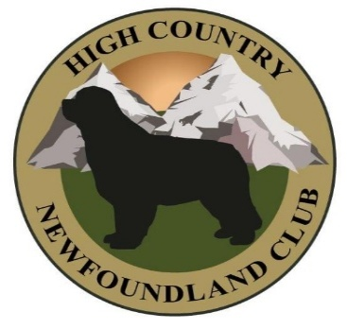
High Country Newfoundland Club
Serving Newf Fanciers in Colorado, New Mexico, Utah, and Wyoming

HIGH COUNTRY NEWFOUNDLAND CLUB, INC. MEMBERSHIP APPLICATION
Date Rec’d_________________________ Ck. & Amount_______ Published:__________ Date Mbrs:__________________________________
General Members must live in Colorado, New Mexico, Utah or Wyoming. Two sponsors who are General Members in good standing must sign an application
TYPE OF MEMBERSHIP APPLIED FOR: (please circle choice)
General (In Region) (voting, includes Newsletter- Single Person Voting Membership) $25.00
Family (2 named members who can both vote, of the same household who are 18 years of age or older) $30.00
Affiliate (Out of Region) (Non-voting, includes Newsletter) $10.00
Junior Membership only (ages 8-18) (non-voting – includes Newsletter) $5.00
Honorary (Voting) (voted by Board, no membership fees required)
I (we) hereby apply for membership in the HIGH COUNTRY NEWFOUNDLAND CLUB, INC. If approved for membership, I (we) agree to abide by the Constitution and By-Laws of High Country Newfoundland Club, Inc. and the rules of the American Kennel Club, Inc.
NAME(s):________________________________________________________________________________________________________________
_______________________________________________________________________________________________________________________
ADDRESS: _____________________________________________________________________________________________________________
CITY: __________________________STATE__________ZIP CODE:_________PHONE: Home__________________________________________
FAX # _____________________________E-Mail address_______________________________________________________________________
Are you a member of the Newfoundland Club of America? __________________
What other dog clubs do you belong to:__________________________________________________________________________________
Newfoundland Dog Ownership (Please include registered name, call name, call name, color, date of birth, AKC registration number, breeder) _______________________________________________________________________________________________________________
______________________________________________________________________________________________________________________
Applicant Signature and Date Shared Applicant Signature and Date
_______________________________ _________________________________
Note to sponsors: By sponsoring this/these applicants, you take on the responsibility of calling them and inviting them to participate in club functions during the initial application process period.
Sponsor’s signature and date Sponsor’s signature and date
______________________________ _________________________________
Revision approved on August 24, 2025
Please send completed application with applicable fee, to: Noreene Rodgers, Membership Chairman, 959 S Oakcrest Ave, Casper, WY 82601 Phone: 307-259-7200 or email to hcncsecretary@gmail.com To pay by PayPal: https://www.paypal.com/ncp/payment/FGLZUC5WBH5G8

Sharing your Newfie expertise is just one way you can help others within HCNC. Below is a list of codes. If you have expertise in any of these areas would be willing to mentor others as part of your club service, please circle the code below.
This information will be included as part of the membership directory so others interested in learning can contact you for help, ideas, etc.
A Agility
B Boarding
C Conformation (Evaluation, Instruction, Handling)
D Draft Work
E Education (General Public, New or Perspective Owners, Workshops)
F Foster
G Grooming
H Health Issues
I Internet (Webmaster, Updating Home Page, Mass Mailings)
J Judges Education
M Mentor Education
O Obedience
P Puppies (BL = Black; BR = Brown; G = Gray; L = Landseer)
R Rally
S Stud (BL = Black; BR = Brown; G = Gray; L = Landseer)
T Tracking
Th Therapy Visits
U Rescue (Transportation; Database Upkeep; Surrender & Applicant Liaison, etc.)
V Volunteer (Committee Chair, Board Member, Fun Match, Hospitality, Parades)
Specify Interest_____________________________________
W Water Rescue Work
Other_____________________________________________

